**Motile strain of fluorescent *Escherichia coli* move following increasing concentration of nutrients**

*Lucile Szpiro, Régine Roncucci, Cécile Crapart, Floriane Coulmance--Gayrard*

**Abstract**

Microbiology is a specific field that study microorganisms such as *E.coli*. Many studies have been done and our knowledge considering this bacteria had largely increased within the years. Our main goal here was to study fluorescence and link it to biology and chemistry. We wanted to know if Red Fluorescent Protein (RFP) could have an impact on motility in *E.coli* while they were placed on a food gradient condition. Does RFP expression have an influence on *E.coli’*s response to a gradient ? Here we show that RFP *Escherichia coli* respond to a food gradient. It was known that *E.coli* use their flagella to move and that they can’t survive without any food. This findings suggest that they use their flagella to move toward the food and not for any other purpose. So here we have a large discovery of *E.coli*’s behaviour. It shows that their main goal as individuals but more largely as a group is to grow and maintain their survival. As this is now proved, what could be interesting is to see if there is a competition between different strains, species of *E.coli* in their quest for food.

|  |  |
| --- | --- |
|  |  |

***Escherichia coli* can move to reach nutrients**

RFP *Escherichia coli*, a simple model organism to study motility

*Escherichia coli* is bacteria, a one cell organism. This bacteria is largely used in microbiology as it is the simplest organism to study complex mechanisms. Its cell is composed of a membrane, a cytoplasm, and no distinct nucleus. They have a flagella that allow them to move in order to reach food. Food of bacteria is actually all nutrients like sugar, alcohol or amino acids that they need to develop and make some colonies**[1]**. Depending on the nutrients available, their growth can be affected.

There exists many different strains of *E.coli*. Here we use an RFP (Red Fluorescent Protein**[2]**) strain that permit us to easily distinguish them using a fluorescent lamp. RFP’s basic function is to emit light (in the red visible part of light spectrum) in response to a specific light wavelength (558 nm). Depending on where the RFP is expressed within the cell, it can cost different energy.

*E.coli* growth depends on the nutrients in the media

Escherichia coli is a bacteria found in the human body, especially in the lower intestine of warm-blooded body. It estimal growth is at 37°Celsius.

When it is put in a rich media such as LB that contains entire molecules to be simply synthesized without a huge cost of energy, *E.coli* divide each 20 minutes. However, in a minimum media such as M9**[1]**, molecules are dispersed and it cost more energy to synthesize indeed to feed and grow. In minimum media they have the nutrients strictly necessary to survive.

As those bacteria can move thanks to their flagella and need food to grow, we know that they feel the food. So we want to know how they respond to a nutrient gradient**[2]**. Our hypothesis is that the more there is food, the bacteria moves to it and develop more colonies.

**Original devices and methods were created to answer our question**

RFP *E.coli* strain grew in liquid LB, rich medium

First we prepare a culture of RFP strain by inoculated some bacteria in a 10 mL media for one night at 37°C incubator. From this overnight culture, we make some serial dilution in LB until 10-6 factor to have 2 falcons of 10 mL of well feed RFP *E.coli* to put for one night at 37°Celsius incubator again. Our 2 falcons correspond to biological replicates.

Water concentrated at 0.3% of agar **[3]** used for negative controls

Our negative control consist in testing *E.coli* culture on plate without any nutrient gradient. This aims to determine if they are already moving in an homogeneous media with the minimum possible nutrient and in case, in which direction.

For that, we created plates with only water and 0.3% agar. Agar is a mixture of polysaccharide agarose (linear molecule) and agaropectin (smaller molecules). Basically, it provides few sugar for bacteria to survive and grow normally. We did 5 technical replicates.

This media was created in four steps.

1. Filter 1 L of distilled water thanks to 5 filters and one 50 mL syringe. Fill two recipients of 500 mL with filtered water and add 1.5 g of agar in each (agar concentration: 0.3%)
2. Boil recipients for 5 minutes using a microwave (the stopper need to be a little bit open so that is can not explode).
3. Shake it for 2 minutes in order to completely dissolve agar in water.
4. Pipette 25 mL of this boiled solution to fill plates. It should look like jelly after 10 to 15 of drying.

Nutrient gradient physically created by tilling plates**[4]**

To create the nutrient gradient, we used a physical method. We filled half plates with 12.5 mL of LB medium and tilted it ( ± 1/2 cm) in order to have an increasing volume of LB along the plate. After 10 to 15 minutes of drying, LB solidified; the slope thus created determine the nutrient gradient. We then completed plates with 12.5mL of water+0.3% agar.

Purify bacteria to remove them from rich medium before starting experiments

Purify *E.coli* is a technique used here to be sure they are not anymore in contact with any LB medium when experiments starts. Indeed, they could continue to grow on this medium without moving toward food on the plate. We centrifugate them and took out the supernatant to replace it by filtrated water three times.

Then we deposited a drop of 5 µL in each plate at the beginning of the nutrient gradient in the less concentrated region in nutrients.

We took pictures under fluorescent lamp (filter of 588 nm) after 15h, 23h, and 40h. Plates were not placed in an incubator.

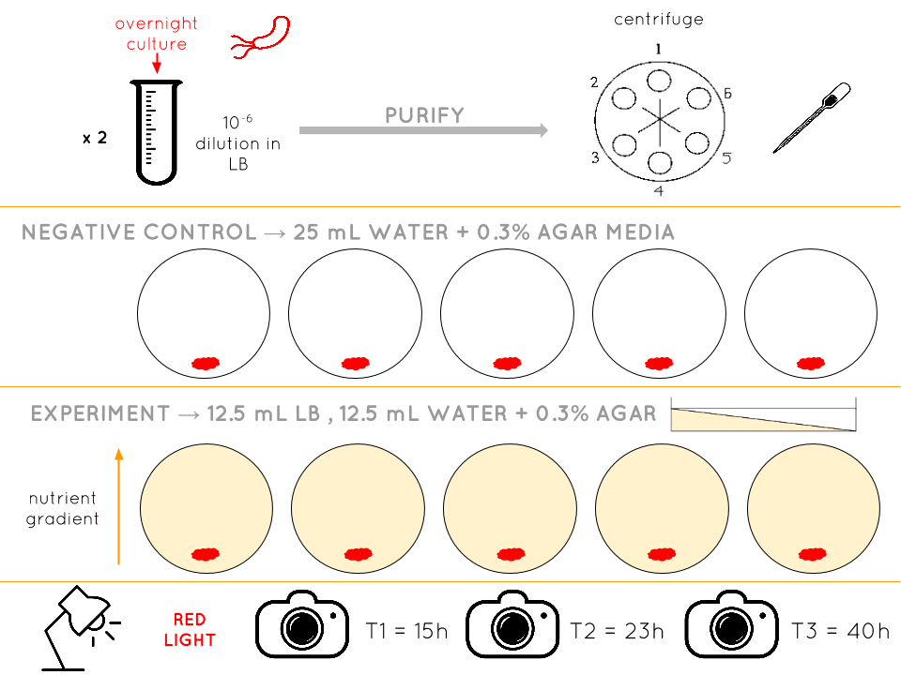

*Figure1. Design an effective protocol to answer our question*

*Detail of the prepared E.coli cultures and how we kept them for experiments*

*Negative control with only water an agar at 0.3% concentration, 5 technical replicates*

*Experiment itself with Lb nutrient gradient on 5 plates corresponding to 5 technical replicates*

*When and how we collect data*

**Breakdown plates in areas and a implementation of new formula to analyse data**

Using plate areas to normalized analysis

To evaluate the bacterial response to the nutrient gradient, we divide plates in five distinct areas (1.8 cm each). Area 1 correspond to the region of the plate less concentrated in nutrients wheres area 5 is the higher concentrated side (see Supplementary materials, figure 4). The breakdown of plates allowed us to simplify the pictures analysis and normalize it. It indeed helped to easily determine if some bacteria effectively move toward the gradient to develop a colony in a more conducive environment. Thus, we considered two parameters indicating *E. coli* response to the nutrient gradient: the number of colonies and their size in each area.

First response indicator: Colonies’ number along the gradient at 3 times

*We plot the number of colonies depending on the area and we made three lines for the three times. The first graph represent our controls and the second the experiment.*

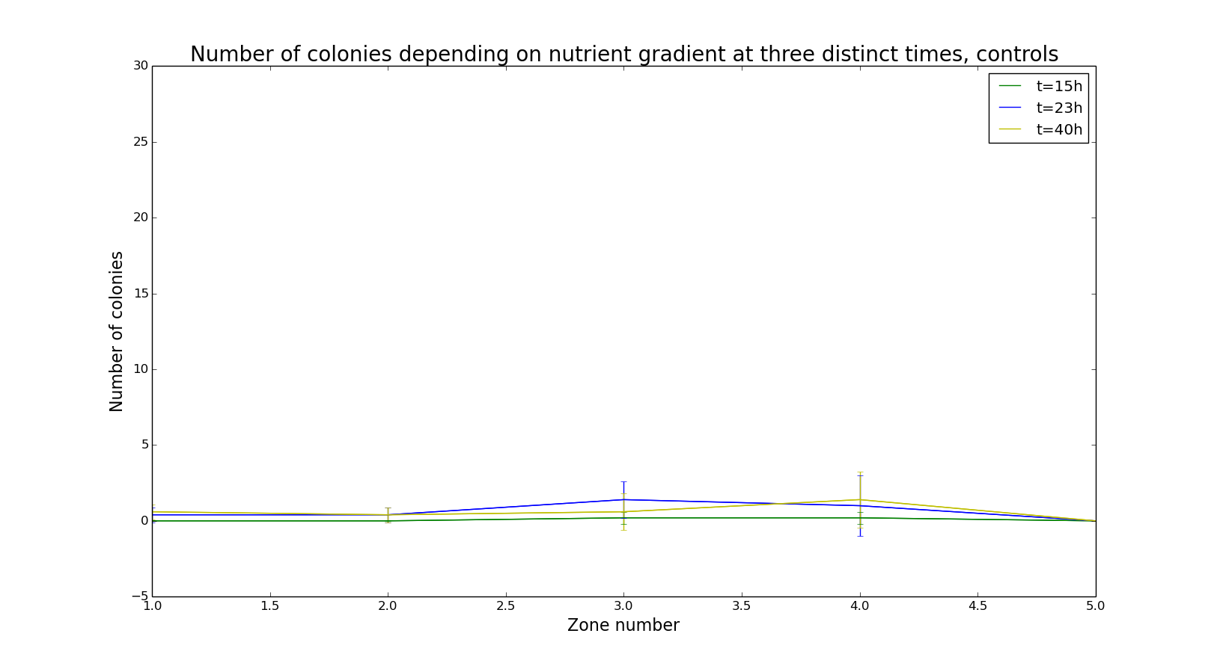

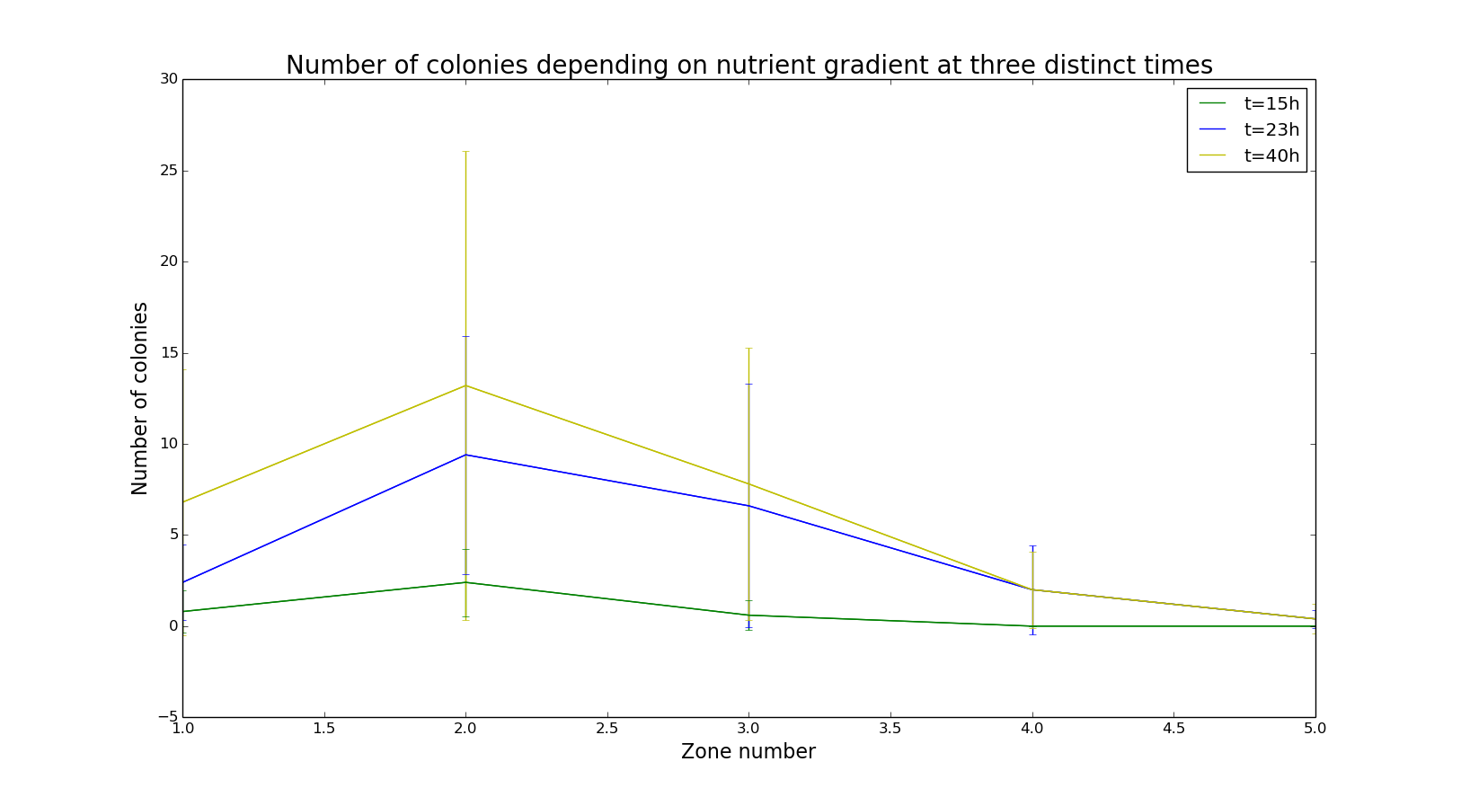

The nutrient gradient is represented in the x-axis by the area number.

Our controls (see Supplementary materials) indicated that there were no developed colonies in any areas of plates without nutrient gradient over the entire experiment. Therefore the response observed in test is necessarily due to the nutrient gradient in the plate.

The average number of new colonies that appeared in each area over time has been represented (see figure). The number of colonies globally increases over time.After 15h, colonies are still mostly in areas 1 and 2. However, ... colonies appeared in areas 2, 3 4 and even 5 more far away from the starting point of bacteria after 23h. As most of the colonies developed in area 2 we assumed that bacteria stopped moving forward when the environment provide enough nutrient to grow. It seems to be confirmed by the measure after 40h: most of colonies are still developing in area 2 although …

We can expect that after a longer time, the number of colonies found in areas 4 and 5 will increase and be higher than in preceding areas were nutrients will have already been used.

Second response indicator: Colonies’ size along the gradient at 3 times

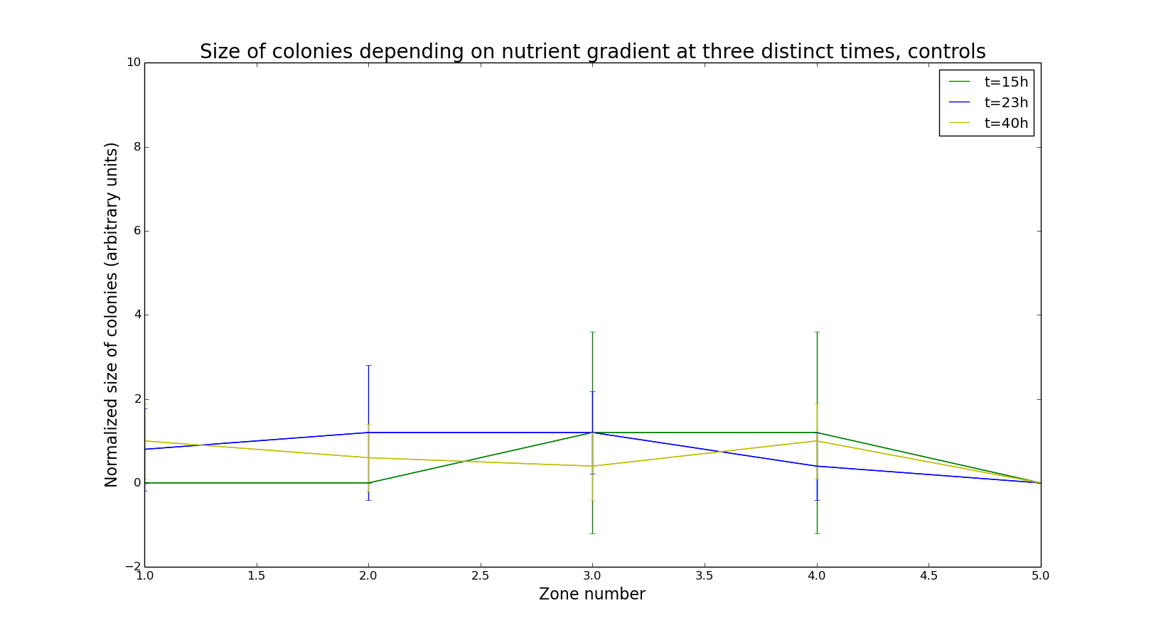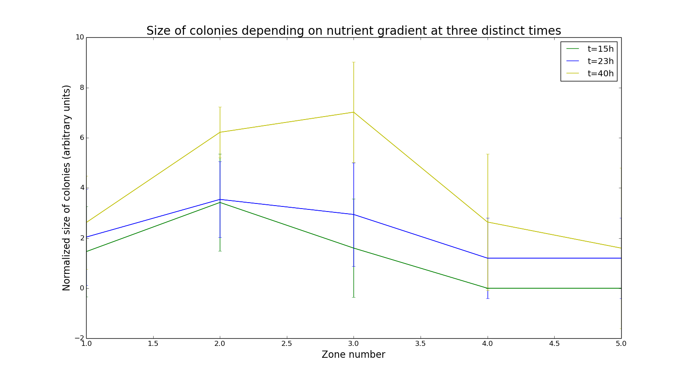.

To determine the size of our colonies we establish a scale, the littlest one were normalise at 1 and the hugest one at 16 it was an arbitrary scale and the determination of the size was made by eyes.

The average size of counted colonies has also been plotted depending on the areas where they were counted. It shows that the colonies in area 2 increased in size. It verify our previous hypothesis : bacteria has enough nutrients in area 2 to start growing colonies. After a longer time, the size of bacteria should be higher in are 5 than in preceding areas because bacteria will not be limited by nutrients quantity

A new rating to analyse our data

Then we try to take into account all the parameters that could reveal a response to a gradient : the advancement of the colonies through the gradient ( define by the areas), the number of colonies and their size. So we sum for each area the product of the number of colonies (0 to 27), the average of the size (0 to 16) and the squared area (1 to 25): $Σ area{{}^{2}×number of colonies ×average size}^{}$ In order to give more or less the same weight to the parameter we decide to put squared the area. We obtain this curve:

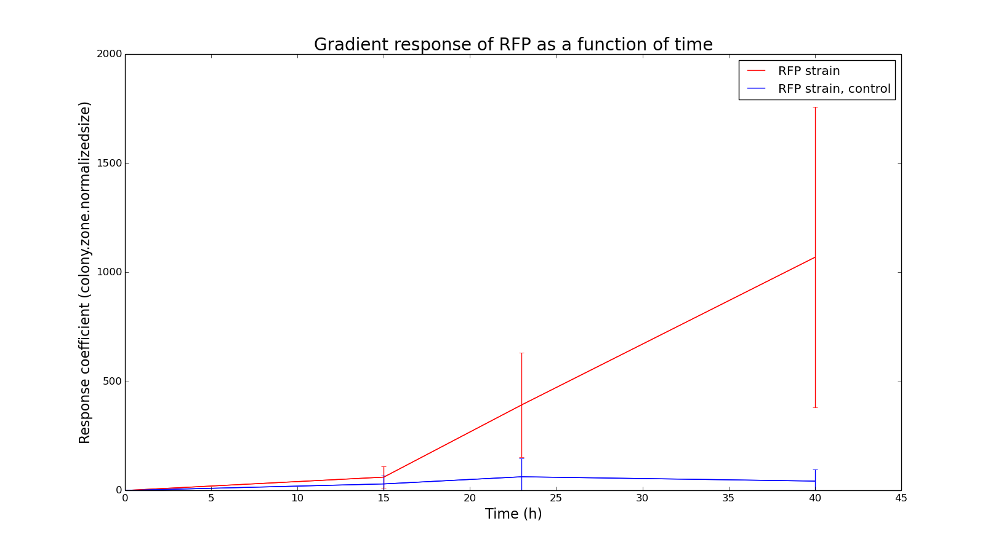

**RFP E. coli respond to a gradient of nutriments**

According to all parameters, we can conclude that RFP *E. coli* respond to food gradient. This response get higher and higher with the time. We also observe huge error bars due to stabilisation of colonies. Indeed, when they have found enough food, there is no need to move toward the most concentrated area of the plate.

**Avoid some mistakes will help improve our study**

We observe that most of colonies stay in area 2 where they have enough food to feed. So instead of putting them on the opposite side from the gradient we should have put them in the middle of the place. Thus we would be able to determine if they go through the gradient or not. In fact, they can move against the gradient.

Instead of putting them in only water + 0.3% agar for negative control, we should have done half LB, half water + 0.3% agar without gradient. This would allow us to base our experiments on a real comparison with same parameters.

**Interactions between different *E.coli* strains can affect their motility**

Here we only studied the influence of a nutrient gradient on satiated bacteria. But our first aim was to compare the response to a gradient of starving and satiated *E.coli*. So the next step is to grow *E.coli* on a minimum media and then expose them to a gradient of food. With the same analysis as described before, we would be able to conclude about the existing response difference or not.

Knowing that *E.coli* have specific chemical signals**[5]** to recognize each other, a continuation to our work would be to study those interactions in gradient conditions. Actually, bacteria of the same speci have their own signal that no other species can detect. But it also exists signals that can be common to different species and even for all species.

For those experiments, we would, in addition to starving and satiated RFP *E.coli*, grow GFP *E.coli* and also make them starve or feed them. In that case we will be able to study the impact of interactions between same strain but also between different strains in each starving or satiated conditions by putting them on the same plates.

**A special thank to**

Daniel Kearns that was pleased to answer our question and gave us advices regarding our experiment.

Tamara Milosevic and Aïmen El Assimi for staying in the lab while we had some troubles with our devices.

Paul-Henry Baranek for helping us think and coordinate team work.

**Bibliography**

**Scientific articles**

**[1] →**

**[2] →** [Surface Growth of a Motile Bacterial Population Resembles Growth in a Chemostat, Daniel A. Koster, Avraham Mayo, Anat Bren and Uri Alon](https://www.weizmann.ac.il/mcb/UriAlon/sites/mcb.UriAlon/files/1-s2.0-s0022283612007401-main_0.pdf)

**[3] →** A field guide to bacterial swarming motility [Daniel B. Kearns](http://www.ncbi.nlm.nih.gov/pubmed/?term=Kearns%20DB%5Bauth%5D)

**[4] →** [Laboratory Protocols in Applied Life Sciences, Prakash Singh Bisen](https://books.google.fr/books?id=NUjSBQAAQBAJ&pg=PA748&lpg=PA748&dq=pouring+plates+with+nutrient+gradient&source=bl&ots=zu87X5beor&sig=l6VRLxuiUEM-uvsDZg8nqZjl6SM&hl=en&sa=X&redir_esc=y#v=onepage&q=pouring%20plates%20with%20nutrient%20gradient&f=false)

**[5] →**

**[6] →**

**[7] →**

**[8] →**

**Sites web**

**[1] →** [Nutrition et croissance des bactéries](http://www.biologiemarine.com/micro/nutrition.htm)

**[2] →** [RFP Proteine](https://www.thermofisher.com/fr/fr/home/life-science/cell-analysis/fluorophores/red-fluorescent-protein.html)

**Supplementary material**

* **Document “RFPdata.tsv”**
* **Code “ecolor3.py”**
* **Document “moreresults.pdf”**